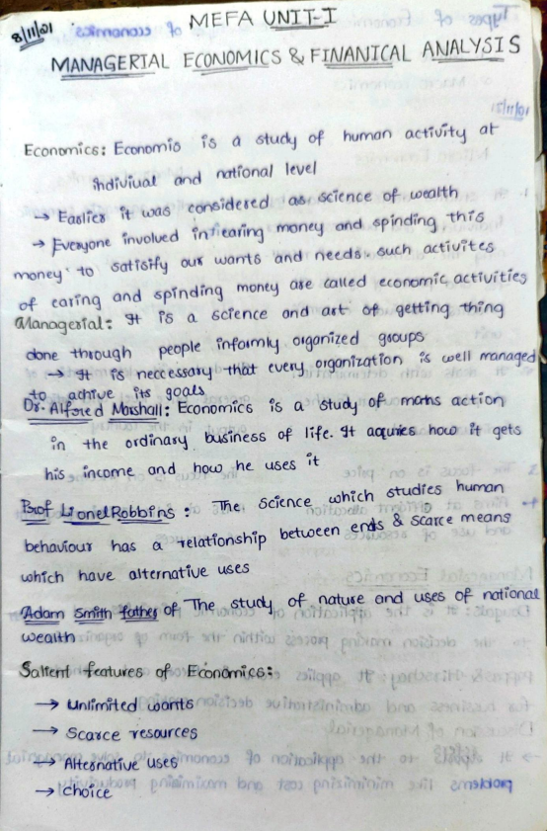**Scanned by Scanner Go**

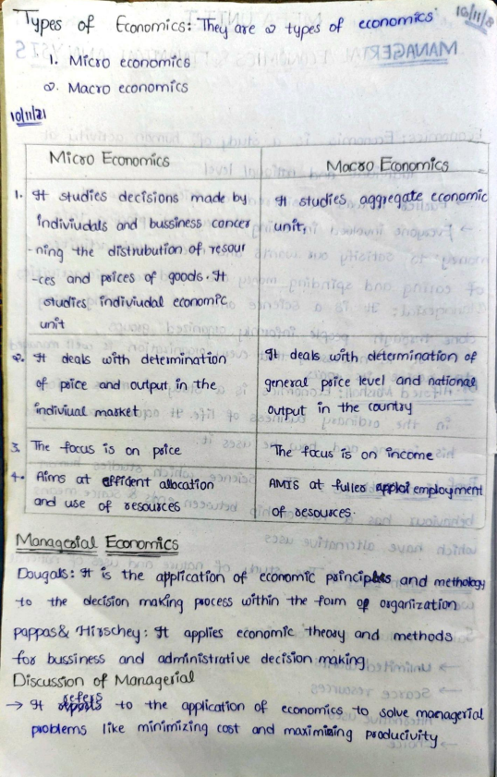**Scanned by Scanner Go**

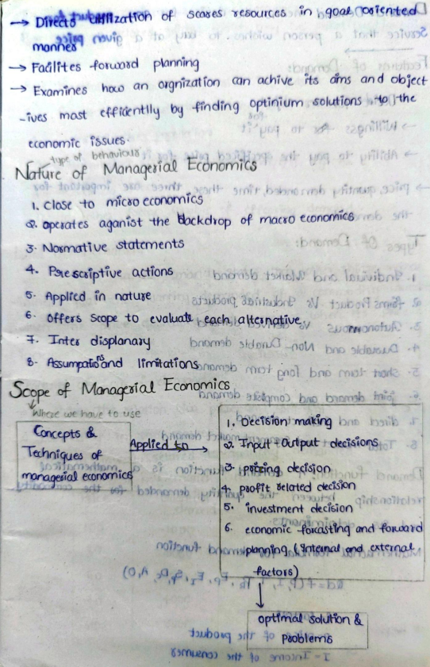**Scanned by Scanner Go**

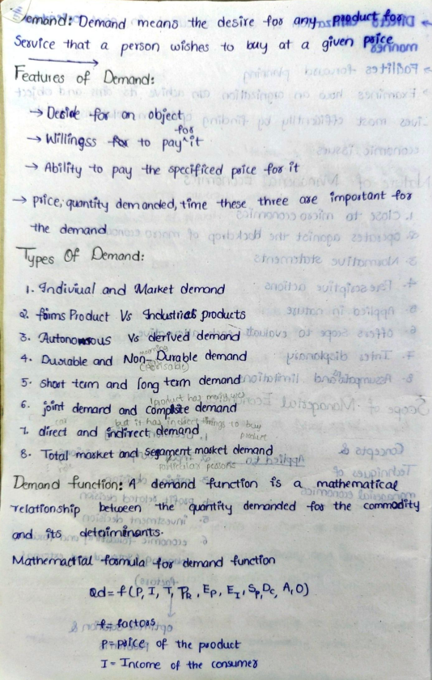**Scanned by Scanner Go**

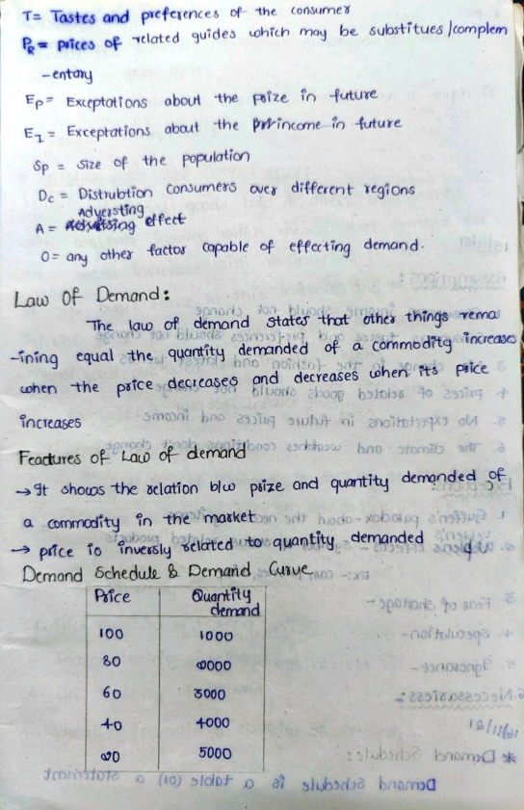**Scanned by Scanner Go**

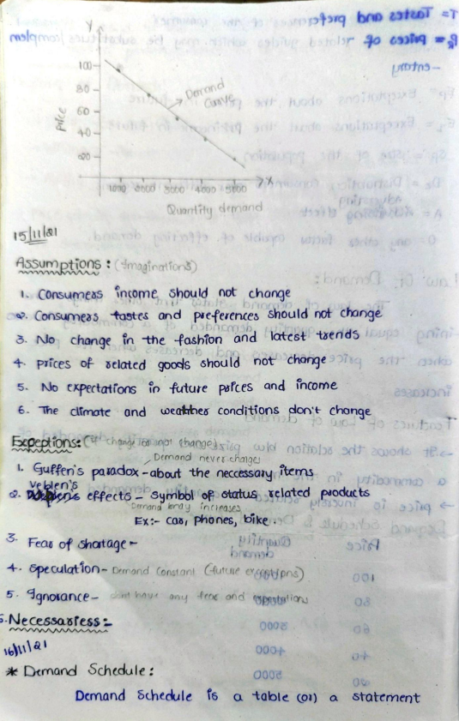**Scanned by Scanner Go**

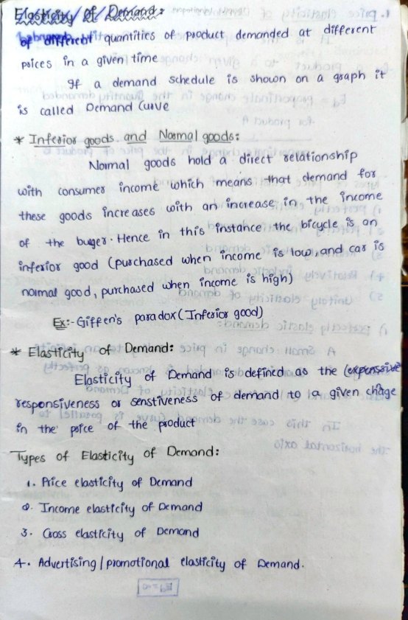**Scanned by Scanner Go**

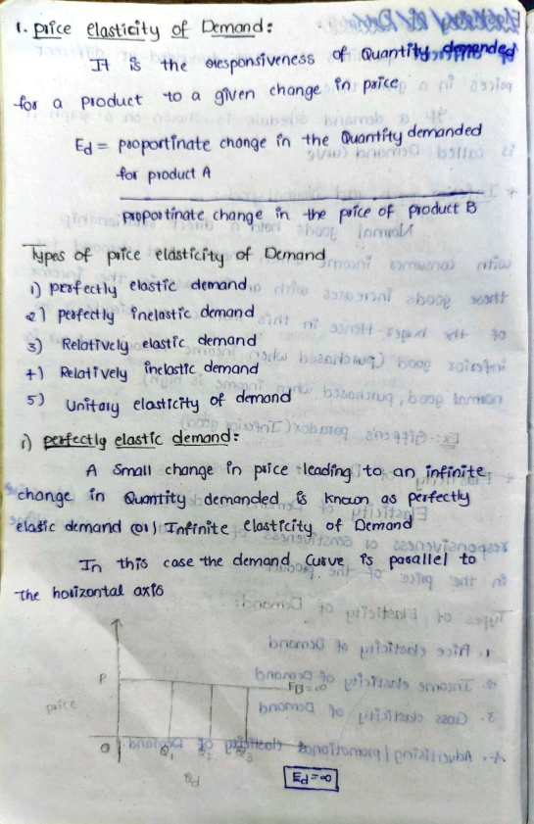**Scanned by Scanner Go**

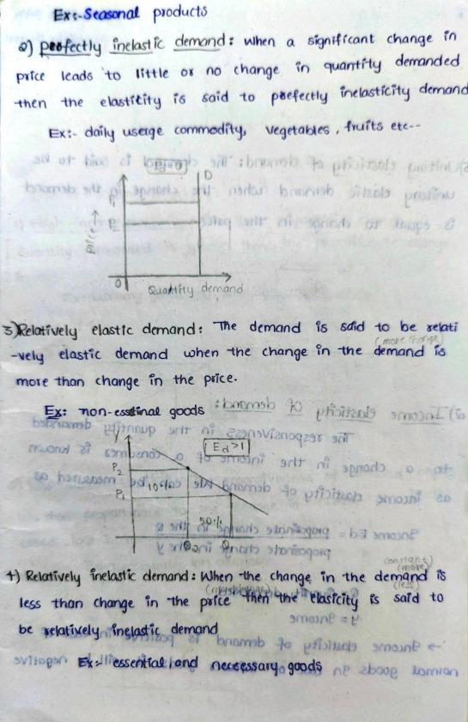**Scanned by Scanner Go**

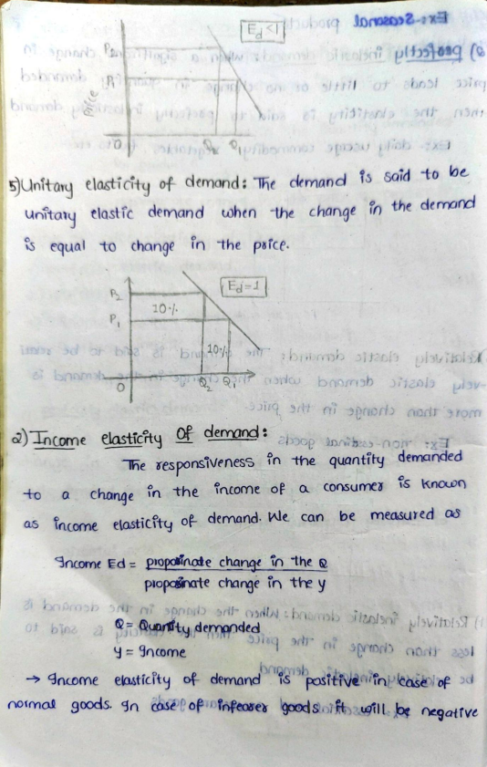**Scanned by Scanner Go**

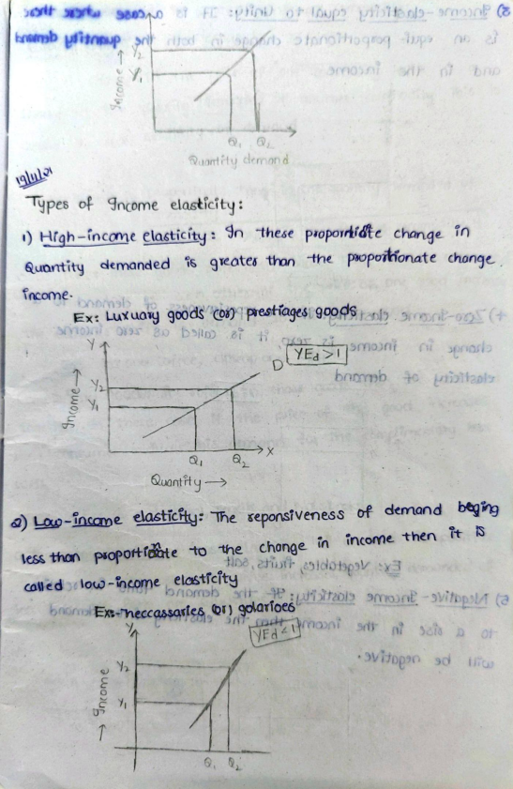**Scanned by Scanner Go**

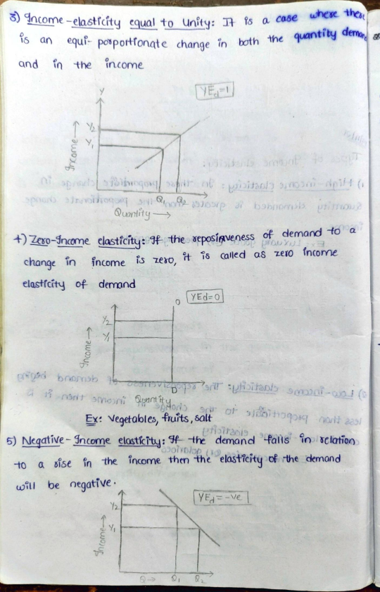**Scanned by Scanner Go**

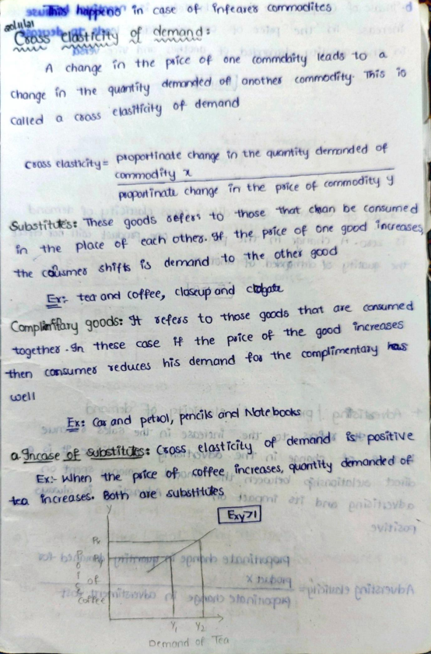**Scanned by Scanner Go**

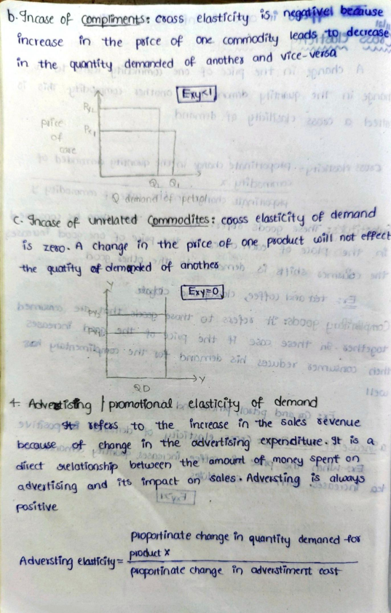**Scanned by Scanner Go**

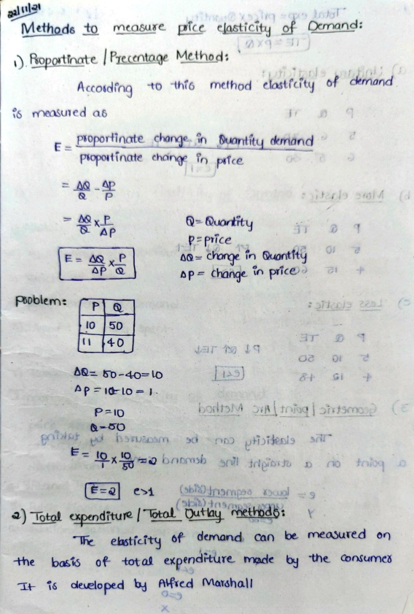**Scanned by Scanner Go**

**Scanned by Scanner Go**

**Scanned by Scanner Go**

**Scanned by Scanner Go**

**Scanned by Scanner Go**

**Scanned by Scanner Go**

**Scanned by Scanner Go**

**Scanned by Scanner Go**

**Scanned by Scanner Go**

**Scanned by Scanner Go**

**Scanned by Scanner Go**

**Scanned by Scanner Go**

**Scanned by Scanner Go**

**Scanned by Scanner Go**

**Scanned by Scanner Go**

**Scanned by Scanner Go**

**Scanned by Scanner Go**

**Scanned by Scanner Go**

**Scanned by Scanner Go**

**Scanned by Scanner Go**

**Scanned by Scanner Go**

**Scanned by Scanner Go**

**Scanned by Scanner Go**

**Scanned by Scanner Go**

**Scanned by Scanner Go**

**Scanned by Scanner Go**

**Scanned by Scanner Go**

**Scanned by Scanner Go**

**Scanned by Scanner Go**

**Scanned by Scanner Go**

**Scanned by Scanner Go**

**Scanned by Scanner Go**

**Scanned by Scanner Go**

**Scanned by Scanner Go**

**Scanned by Scanner Go**

**Scanned by Scanner Go**

**Scanned by Scanner Go**

**Scanned by Scanner Go**

**Scanned by Scanner Go**

**Scanned by Scanner Go**

**Scanned by Scanner Go**

**Scanned by Scanner Go**

**Scanned by Scanner Go**

**Scanned by Scanner Go**

**Scanned by Scanner Go**

**Scanned by Scanner Go**

**Scanned by Scanner Go**

**Scanned by Scanner Go**

**Scanned by Scanner Go**

**Scanned by Scanner Go**

**Scanned by Scanner Go**

**Scanned by Scanner Go**

**Scanned by Scanner Go**

**Scanned by Scanner Go**

**Scanned by Scanner Go**

**Scanned by Scanner Go**

**Scanned by Scanner Go**

**Scanned by Scanner Go**

**Scanned by Scanner Go**

**Scanned by Scanner Go**

**Scanned by Scanner Go**

**Scanned by Scanner Go**

**Scanned by Scanner Go**

**Scanned by Scanner Go**

**Scanned by Scanner Go**

**Scanned by Scanner Go**